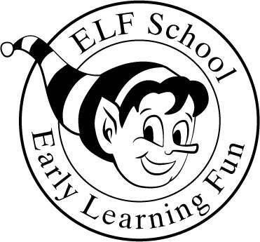

Early Learning Fun School
At Boyds Presbyterian Church
19821 White Ground Road P.O. Box 305
Boyds, MD 20841 (301)-540-3370 elfschoolboyds@gmail.com elfschool.org

Philosophy
Our ultimate goal as educators is to build self-esteem. With a positive self-image, successful experiences follow. Early Learning Fun preschool (ELF) is a nurturing environment, staffed with dedicated professionals who will facilitate learning based on trust, respect, and integrity.
At ELF preschool, we have created an age-appropriate curriculum that involves cognitive skills and social interaction. We enhance each day by involving the children in art, music, writing skills, free play, and circle time discussions.
We provide a daily snack followed by outdoor play in a safe, wholesome atmosphere, close to nature, away from busy streets, and with plenty of room to explore!
Tuition Hours*** 9:30am--1:00pm***Bring a lunch!
Class Schedule Yearly Tuition Monthly Tuition
2 days/week $2790.00 $310.00
3 days/week $3825.00 $425.00
4 days/week $4680.00 $520.00
5 days/week $5580.00 $620.00
We offer a 10% discount for siblings enrolled. Tuition is based on a nine-month calendar year with the option to pay monthly. September’s non-refundable payment is due May 15, 2026, which will hold your spot for the 2026/2027 school year. May 2027 tuition is non-refundable and is due August 15, 2026, and October’s tuition is due September 15th. Thereafter, tuition will be due on the 15th of each preceding month. A late fee of $10 will be added after the 20th of the month. Tuition may be paid monthly, semi-annually, or annually. There will be no reduction in tuition for absences whether caused by illness, vacation, weather, or any other reason. One month’s notice needed for withdrawal.
Admission
Children are eligible for admission, regardless of race, color, or national origin. ELF will hold open enrollment first to members of Boyds Presbyterian Church, then to families with siblings currently enrolled at ELF, and then to children in the community. To enroll, complete an application, enclose a $100 non-refundable registration fee, and return it to the ELF school on or after the
registration date of 02-02-26. (Existing students/siblings registration is Jan. 5, 2026)
Staff
ELF is licensed by the Maryland State Board of Education Office of Childcare. The school meets all requirements regarding the curriculum, policies, facilities, and staff qualifications. The staff are professional and hired without regard to race, religion, or national origin. Teacher: Student Ratio-1:12 plus teacher aides.
Early Learning Fun School
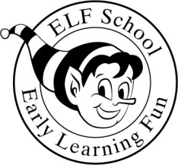
Location: Boyds Presbyterian Church Office Use
19821 White Ground Road Date Rec’d __________________
P.O. Box 305 Registration Fee______________
Boyds, MD 20841 Check #_____________________
(301)-540-3370 elfschoolboyds@gmail.com

Child’s Full Name____________________________________________________Male/Female
Circle one
Date of Birth_______________________Place of birth_______________________________

Address Number/Street___________________________________________________________

City/State/Zip___________________________________________________________

Home Phone____________________________E-mail___________________________

Father Mother

Full Name__________________________________ ________________________________

Employer__________________________________ ________________________________

Occupation_________________________________ ________________________________

Work Phone________________________________ ________________________________

In which program would you like your child to be enrolled? 9:30am-1:00pm
 | CLASS | AGE
 | T TH am | Birthday Between 9-01-23 to 2-28-24
 | M WF am | 1-01-23 to 12-31-23
 | MWF am | 10-01-22 to 6-01-23
 | TTHF am | 1-01-22 to 12-31-22
 | MTWTH am | 1-01-22 to 12-31-22
 | K PREP M—F am | 8-01-21 to 8-31-22
 | Science Enrichment—1:00-2:00 pm | For those in 4 yr. old classes--$110 MW
 | Science Enrichment—1:00-2:00 pm | For those in 4 yr. old classes--$110 TTH

Please enclose the registration fee of $100, which is non-refundable. Make checks payable to ELF school or Zelle at elfschoolboyds@gmail.com. The fee includes special risk group accident insurance for students covering minor playground accidents. Completion of this form is a request for admission to the ELF school. Upon your child’s acceptance, additional forms will be required from our website, Elfschool.org, by 8/1/26.

DON’T NEED THIS FORM? GIVE IT TO A FRIEND!

________________________________________________________ ______________
Parent/Guardian Signature Date

